4. Implement Histogram Equalization Using OpenCV
Aim: To implement histogram equalization on a given image and compare it with the original image using OpenCV.
Procedure
- Import the OpenCV library.
- Read the input image.
- Convert the image into grayscale.
- Apply histogram equalization using cv2.equalizeHist().
- Display the original image and the equalized image.
Code
import cv2

img = cv2.imread("sample.jpg")

gray = cv2.cvtColor(img, cv2.COLOR_BGR2GRAY)

equalized = cv2.equalizeHist(gray)

cv2.imshow("Original Image", gray)
cv2.imshow("Histogram Equalized Image", equalized)

cv2.waitKey(0)
cv2.destroyAllWindows()
Input
An image named sample.jpg saved in the same folder as the Python program.
Output
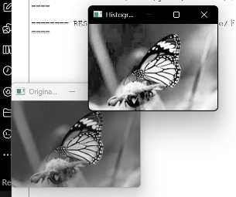
Result
Histogram equalization was successfully implemented using OpenCV to improve the contrast of the input image and compare it with the original image.

